**CHAPTER 1**

**INTRODUCTION**

**1.1 Description**

In the dynamic landscape of healthcare, early identification of vitamin deficiencies plays a pivotal role in preventing a myriad of health issues. Taking inspiration from the forward-thinking concepts outlined in the IEEE paper titled "Vitamin Deficiency Detection Using Image Processing and Neural Network," our project endeavours to transform these ideas into a practical and user-friendly Android application.

The existing method for detecting vitamin deficiencies, while accurate, faces challenges that our proposed system seeks to address. The traditional approach, reliant on laboratory analyses and blood sample testing, is accurate but characterized by a sluggish process. The time-consuming nature of procedures, high costs, and dependency on specialized facilities limit the accessibility of vitamin deficiency screening.

Now, let's shift our focus to the innovative aspects of our project—the proposed system. Our Android application harnesses the power of modern technologies, specifically Convolutional Neural Networks (CNN) and Fuzzy Logic. These advanced technologies empower our system to intelligently analyse images, providing accurate insights into potential vitamin deficiencies.

What sets our system apart is its emphasis on efficiency. Users can capture images of specific body parts—eyes, nails, lips, and tongue—eliminating the need for invasive blood sample testing. This not only expedites the diagnostic process but also enhances user comfort and convenience.

Cost-effectiveness is a cornerstone of our project. By reducing reliance on expensive laboratory procedures, we aim to make vitamin deficiency screening accessible to a broader demographic. Our vision is to create a system that seamlessly combines accuracy with enhanced convenience. The proposed Android app serves as a user-friendly alternative, putting a powerful health management tool in the hands of individuals.

In summary, our project represents a convergence of cutting-edge technology and proactive healthcare. We aspire to bridge the gap between accuracy and accessibility, revolutionizing the landscape of vitamin deficiency detection. Our Android application is designed not just to diagnose deficiencies but to empower users to take charge of their health effortlessly and efficiently.

**1.2 Objectives**

**1. Develop an Android Application:** Create a user-friendly Android application that serves as a platform for vitamin deficiency detection.

**2. Implement Advanced Technologies:** Utilize Convolutional Neural Networks (CNN) and Fuzzy Logic to develop intelligent image analysis capabilities within the application.

**3. Enable Image Capture for Specific Body Parts:** Allow users to capture images of specific body parts (eyes, nails, lips, and tongue) for analysis, eliminating the need for invasive blood sample testing.

**4. Build a Comprehensive Database:** Establish and expand a comprehensive database of images showing symptoms and deficiencies for training the neural network.

**5. Train the Neural Network:** Train the neural network using the collected database to recognize symptoms related to vitamin deficiencies with high accuracy.

**6. Integrate TensorFlow Lite Model:** Integrate a TensorFlow Lite model into the Android application for efficient image processing and comparison with the training dataset.

**7. Provide Accurate Deficiency Predictions:** Ensure that the application accurately predicts potential vitamin deficiencies based on the user's captured images.

**8. Offer Personalized Dietary Recommendations:** Provide users with a recommended dietary plan based on identified deficiencies, suggesting specific fruits and vegetables for improvement.

**9. Ensure Cost-Effectiveness:** Design the system to be cost-effective by reducing dependency on costly laboratory procedures, making vitamin deficiency screening more accessible.

**10. Enhance Convenience and User-Friendliness:** Create a user-friendly alternative to traditional vitamin deficiency detection methods, enhancing convenience and encouraging widespread adoption.

**11. Contribute to Healthcare Awareness:** Contribute to the advancement of healthcare by raising awareness about vitamin deficiencies and promoting proactive health management.

**12. Validate Accuracy through Testing:** Conduct testing phases to validate the accuracy of the application's predictions and ensure reliability in real-world scenarios.

**13. Seek Feedback from Users and Experts:** Obtain feedback from users and medical experts to continuously improve the application's functionality and accuracy.

**14. Promote Education on Nutritional Awareness:** Incorporate educational components within the application to increase user awareness about nutritional needs and the importance of a balanced diet.

**CHAPTER 2**

**LITERATURE SURVEY**

**"Vitamin Deficiency Detection Using Image Processing and Neural Network",** Vitamin deficiency detection has been a longstanding concern in healthcare, prompting continuous exploration and innovation in diagnostic methodologies. The traditional approach, as outlined in various studies, primarily relies on laboratory analyses and blood sample testing. While acknowledged for its accuracy, this conventional method is characterized by a sluggish process, time-consuming procedures, high costs, and a dependency on specialized facilities and trained medical professionals.

The study titled "Vitamin Deficiency Detection Using Image Processing and Neural Network" (Ahmed Saif Eldeen, et al.) serves as a cornerstone in the literature, introducing a transformative concept by leveraging advanced technologies. The paper underscores the challenges of the current method and proposes a novel approach using Convolutional Neural Networks (CNN) and Fuzzy Logic for intelligent image analysis.

One of the key criticisms of the traditional method is its slowness. Eldeen et al. acknowledge this drawback and propose a system that addresses the time-consuming nature of vitamin deficiency detection. By introducing an Android application, users can capture images of specific body parts, namely the eyes, lips, tongue, and nails, facilitating a faster diagnostic process without invasive blood sample testing.

The literature review highlights the challenges associated with the current approach, including the time-consuming procedures involved in sample collection, analysis, and result reporting. Eldeen et al.'s work aims to streamline this process, providing a more efficient alternative that aligns with the contemporary need for rapid and accessible healthcare solutions.

Cost-effectiveness emerges as a central theme in the literature survey, with Eldeen et al. recognizing the financial burden associated with traditional laboratory procedures. By reducing dependency on costly methods, the proposed system seeks to make vitamin deficiency screening more accessible to a broader demographic.

The dependency on specialized facilities and trained medical professionals is identified as a bottleneck in the scalability of vitamin deficiency detection. Eldeen et al.'s approach breaks away from this dependency by introducing an Android application that puts the power of vitamin deficiency detection directly into the hands of users, enhancing convenience and user-friendliness.

The literature survey thus underscores the pivotal role of the "Vitamin Deficiency Detection Using Image Processing and Neural Network" study in reshaping the landscape of vitamin deficiency diagnostics. Through the integration of modern technologies, efficient image capture, and a user-friendly interface, this project not only addresses the limitations of current methods but also represents a significant leap towards proactive health management and widespread accessibility in the realm of vitamin deficiency detection.

**“Detection and classification of nutrient deficiencies in plants using machine learning”,** Nutrient deficiency detection in plants has long been a concern in agriculture, with a significant impact on productivity and yield. Traditional methods for identifying deficiencies involve visual inspection and manual diagnosis by farmers, which can be subjective and often leads to late interventions. The need for more objective and efficient detection methods has driven researchers to explore innovative approaches.

The study titled “Detection and classification of nutrient deficiencies in plants using machine learning”, emerges as a crucial contribution in the literature, presenting a groundbreaking approach to address the challenges associated with nutrient deficiency detection. The traditional approach of relying on visual symptoms is noted for its limitations, and the paper proposes an intelligent system integrating image processing and artificial neural networks (ANN) for automated classification.

Traditional methods of nutrient deficiency detection have relied heavily on visual assessments, often leading to delayed or ineffective interventions. The study recognizes this limitation and introduces a novel system that utilizes image processing techniques and machine learning to automate the classification of nutrient deficiencies.

The literature review underscores the limitations of the traditional approach, where farmers struggle to detect nutrient deficiencies accurately, leading to reduced productivity. The work aims to revolutionize this process by introducing an advanced system capable of classifying nutrient deficiencies based on the visual symptoms exhibited by plants.

The challenges associated with nutrient deficiency detection, such as the inability to identify symptoms accurately and the resultant decrease in productivity, are addressed by the proposed system. The study emphasizes the significance of leveraging artificial neural networks and image processing to provide a more objective and timely solution to nutrient deficiency issues.

The study identifies the major nutrients crucial for plants—nitrogen, magnesium, phosphorus, potassium, calcium, and sulphur—and outlines their respective deficiency symptoms. By using a dataset of images depicting these deficiencies, the proposed system is trained to classify and analyse leaves, providing farmers with an efficient tool for early detection.

The literature survey also delves into related works, showcasing various methods employed in nutrient deficiency detection across different plants. The research acknowledges the diversity of approaches, including fuzzy logic, SVM-based techniques, and genetic algorithms, in detecting deficiencies in plants.

In conclusion, the research significantly contributes to the field of agriculture by introducing an intelligent system for nutrient deficiency detection. The integration of image processing and machine learning not only addresses the shortcomings of traditional methods but also empowers farmers with a proactive tool for enhancing crop productivity. This study, with its comprehensive approach and innovative methodology, stands as a cornerstone in reshaping the landscape of nutrient deficiency diagnostics in agricultural settings.

**“Detection of Plant Leaf Nutrients Using Convolutional Neural Network-Based IoT Data Acquisition”,** Plant leaf nutrient detection has been a focal point in agricultural research, prompting continuous exploration of innovative methodologies. Traditional approaches often involve visual inspection, which is time-consuming, subjective, and prone to human error. The study titled "Detection of Plant Leaf Nutrients Using Convolutional Neural Network-Based IoT Data Acquisition" (R. Sathyavani, et al.) significantly contributes to this field by introducing a technology-driven paradigm shift. The paper emphasizes the challenges in traditional nutrient detection methods and proposes a groundbreaking solution leveraging Convolutional Neural Networks (CNN) and Internet of Things (IoT) devices.

Historically, nutrient deficiency detection in plants has relied on visual symptoms, a process that is both labour-intensive and limited by human perception. Sathyavani et al.'s work recognizes these limitations and introduces an innovative approach using CNN for automated nutrient analysis based on leaf images captured by IoT devices. This novel methodology not only enhances accuracy but also expedites the detection process.

The literature survey highlights the inadequacies of traditional visual inspection methods, emphasizing the subjective nature of human observation and the inefficiency in analysing large datasets. Sathyavani et al.'s approach revolutionizes this by introducing a technology-driven solution that automates the nutrient detection process, mitigating the shortcomings of manual inspection.

The study brings attention to the importance of timely nutrient detection in plants for optimal growth and productivity. Traditional methods often lead to delayed identification of nutrient deficiencies, impacting the overall health of plants and resulting in significant agricultural losses. Sathyavani et al.'s CNN-based approach addresses this issue by providing a real-time, automated system capable of processing large datasets efficiently.

Efficiency and accuracy are crucial factors in nutrient detection, especially when dealing with a variety of plant species. Sathyavani et al. conduct a comprehensive analysis, utilizing a 5-fold cross-validation on a dataset comprising 3000 images from various disorders in five different plants. The results demonstrate the superiority of the proposed CNN-based model over existing methods, showcasing its potential for widespread adoption in the agricultural sector.

The literature survey underscores the transformative impact of the "Detection of Plant Leaf Nutrients Using Convolutional Neural Network-Based IoT Data Acquisition" study on the field of plant nutrient detection. By incorporating cutting-edge technologies, such as CNN and IoT devices, the project not only addresses the challenges associated with traditional methods but also presents a scalable and efficient solution for precision agriculture. This research signifies a significant step forward in optimizing plant health and enhancing agricultural productivity through technology-driven nutrient detection.

**“Using Deep Convolutional Neural Networks for Image-Based Diagnosis of Nutrient Deficiencies in Rice”,** Nutrient deficiency detection in plants, particularly in crops like rice, has been a subject of increasing importance for enhancing agricultural productivity. Traditional approaches often involve manual inspection and analysis, which can be time-consuming and labour-intensive. Recent advancements in computer vision and deep learning offer promising alternatives for automating the identification of nutrient deficiencies in crops.

The research paper titled "Deep Learning Approaches for Nutrient Deficiency Identification in Rice Plants" (Authors: Zhe Xu and Xi Guo) contributes significantly to the literature by exploring the application of Deep Convolutional Neural Networks (DCNNs) in the context of nutrient deficiency diagnosis. This study builds upon existing methodologies and introduces innovative techniques to address the limitations of traditional approaches.

A critical aspect addressed by Xu and Guo is the need for accurate and timely nutrient deficiency identification. Traditional methods may involve manual observation, leading to delays in detection. The proposed DCNN-based approach aims to streamline this process, offering a more efficient and automated solution. The authors utilize advanced architectures such as Inception-v3, ResNet50, Nas Net-Large, and DenseNet121 to achieve high levels of accuracy in deficiency classification.

The literature survey emphasizes the advantages of DCNNs over conventional machine learning methods. DCNNs, as demonstrated by Xu and Guo, exhibit superior performance in handling complex image data, allowing for the identification of subtle visual cues associated with nutrient deficiencies. The models are trained on a dataset collected from hydroponic experiments, providing controlled conditions for precise symptom manifestation.

The scalability and generalization of the proposed approach are crucial considerations. Xu and Guo acknowledge the importance of collecting diverse datasets, including outdoor images and field experiments, to enhance the model's ability to identify nutrient deficiencies in real-world scenarios. The paper emphasizes the potential application of the developed model in a mobile diagnosis system, providing a practical tool for farmers and agricultural practitioners.

Cost-effectiveness and accessibility are recurrent themes in the literature survey. By leveraging DCNNs, Xu and Guo contribute to reducing the dependency on costly laboratory procedures. The potential integration of the model into a mobile application aligns with the goal of making nutrient deficiency diagnosis more accessible to a broader demographic.

In conclusion, the literature survey highlights the significant contribution of "Deep Learning Approaches for Nutrient Deficiency Identification in Rice Plants" to the field of agricultural diagnostics.

**CHAPTER 3**

**PROBLEM STATEMENT**

**3.1 Existing System**

The prevailing methodology for vitamin deficiency detection, anchored in traditional laboratory analyses and blood sample testing, stands out for its commendable accuracy. However, this established system confronts a series of formidable challenges, collectively impeding its effectiveness, accessibility, and widespread adoption.

**1. Accurate but Sluggish Process:**

- The method's reliance on laboratory analyses and blood samples ensures precise outcomes, underscoring its accuracy. However, the cost of this precision is a process that unfolds at a sluggish pace. From the collection of samples to the reporting of results, the prolonged duration poses a critical obstacle. In cases where early detection is imperative for addressing vitamin deficiencies effectively, this delay becomes a crucial factor.

**2. Time-Consuming Procedures:**

- The intricate procedures inherent in the conventional approach compound its significant drawback—the time-consuming nature of the process. The extended waiting period for laboratory test results can be exasperating and has the potential to cause delays in crucial interventions. This procedural inefficiency compromises the overall effectiveness of promptly addressing vitamin deficiencies.

**3. High Costs:**

- Another substantial challenge embedded in the existing system is the elevated costs associated with laboratory tests and the demand for specialized facilities. The financial burden imposed by these costs restricts the accessibility of vitamin deficiency screening to a broader demographic. This financial barrier impedes the availability of critical health assessments to a significant portion of the population.

**4. Dependency on Specialized Facilities:**

- The existing methodology's reliance on specialized facilities and the expertise of trained medical professionals, while contributing to accuracy, introduces complexities and limits scalability. The accessibility of such specialized facilities is not universal, and the availability of trained professionals is not widespread. This dependency hampers the broad adoption of vitamin deficiency detection, exacerbating disparities in healthcare accessibility.

**5. Patient Discomfort and Invasiveness:**

- Additionally, the traditional approach involves invasive procedures such as blood sample testing, contributing to patient discomfort. The discomfort associated with these procedures can act as a deterrent, discouraging individuals from undergoing regular screenings for vitamin deficiencies.

**6. Limited Interactivity and User Engagement:**

- The conventional method lacks the interactive and user-engaging features that are becoming increasingly vital in modern healthcare solutions. Patients may find the process less engaging and less likely to encourage active participation in their health management.

In view of these multifaceted challenges, there arises a pressing need for a transformative shift in vitamin deficiency detection methodologies. An alternative approach that is efficient, cost-effective, user-friendly, and capable of ensuring widespread accessibility is imperative to overcome the limitations of the existing system. This shift is crucial for promoting proactive health management and addressing the evolving healthcare needs of diverse populations.

**3.2 Proposed System**

Now, let's get into the exciting part—the proposed system. We're trying to implement latest technology to make vitamin deficiency detection smarter and more user-friendly.

**1. Leveraging Cutting-Edge Technologies:**

- The proposed Android application represents a technological leap forward, harnessing the capabilities of Convolutional Neural Networks (CNN) and Fuzzy Logic. This amalgamation empowers the system to intelligently analyse images, providing precise insights into potential vitamin deficiencies.

**2. Simple Image Capture:**

- Departing from invasive blood sample testing, the proposed system allows users to capture images of specific body parts—eyes, nails, lips, and tongue. This novel approach not only eliminates the discomfort associated with traditional methods but also expedites the diagnostic process. Users can now obtain valuable health information through a simple image capture, redefining the diagnostic experience.

**3. Cost-Effective and Inclusive Solution:**

- The design philosophy of the proposed system strategically reduces reliance on expensive laboratory procedures. This cost-effective approach aims to democratize vitamin deficiency screening, ensuring accessibility for a diverse population. By minimizing financial barriers, our technology becomes a tool for health empowerment, reaching a broader demographic.

**4. User-Centric Design for Enhanced Convenience:**

- Crafted as an Android app, our proposed system prioritizes user experience. The user-friendly design ensures seamless navigation, transforming the diagnostic process into an accessible, convenient, and user-friendly endeavour. This innovation places a powerful health management tool directly into the hands of individuals, fostering a proactive approach to health and well-being.

**5. Tailored Dietary Recommendations for Holistic Well-Being:**

- Going beyond detection, our system offers personalized dietary plans to address identified deficiencies. Users receive recommendations on incorporating specific fruits and vegetables into their diet, promoting not only deficiency correction but also overall health and well-being.

The proposed system for vitamin deficiency detection represents a comprehensive and innovative approach to revolutionize health management. Leveraging cutting-edge technologies such as Convolutional Neural Networks (CNN) and Fuzzy Logic, the Android application ensures a high level of accuracy in analysing images for potential vitamin deficiencies. The integration of these advanced technologies not only enhances the precision of diagnosis but also establishes the system as a frontrunner in the field of health tech.

One of the standout features of the proposed system is its emphasis on efficient image capture. Departing from traditional, invasive blood sample testing methods, users can now capture images of specific body parts, including eyes, nails, lips, and tongue. This novel approach not only streamlines the diagnostic process but also addresses the discomfort associated with conventional methods. The shift towards non-invasive image capture introduces a new dimension of convenience and ease into the realm of vitamin deficiency detection.

A pivotal aspect of the proposed system is its commitment to being a cost-effective and inclusive solution. By strategically reducing reliance on expensive laboratory procedures, the design philosophy aims to democratize vitamin deficiency screening. This strategic approach ensures accessibility for a diverse population, minimizing financial barriers and transforming the technology into a tool for health empowerment. The inclusive nature of the system is geared towards reaching a broad demographic, making health management a universal experience.

The user-centric design of the Android app is meticulously crafted to prioritize a seamless and enjoyable experience for users. The emphasis on user-friendliness ensures that navigating through the application is intuitive and straightforward. By placing a powerful health management tool directly into the hands of individuals, the proposed system fosters a proactive approach to health and well-being. The user-centric approach not only enhances accessibility but also encourages individuals to actively engage in managing their health.

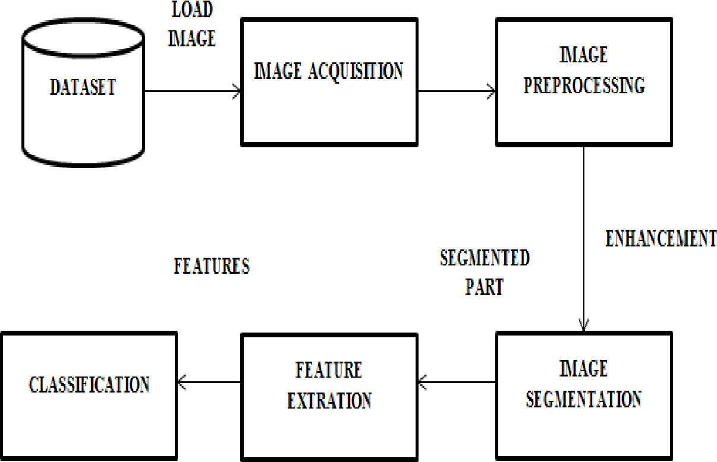

Fig-1: Image Segmentation

Moreover, the proposed system goes beyond detection by providing tailored dietary recommendations for holistic well-being. Users receive personalized dietary plans designed to address identified deficiencies, incorporating specific fruits and vegetables into their daily intake. This holistic approach not only corrects deficiencies but also promotes overall health and well-being, establishing the system as a comprehensive solution for health management.

In summary, the proposed system is a paradigm-shifting initiative that combines technological advancements, efficiency, accessibility, and personalized recommendations to redefine health management. From advanced image analysis to user-friendly design and personalized dietary plans, the system encompasses a multifaceted approach to empower individuals to take control of their health journey.

**CHAPTER 4**

**REQUIREMENT ANALYSIS**

**4.1 Hardware requirements:**

**For development:**

* Processor: Minimum Intel i3 11th gen
* RAM: Minimum 8GB
* Storage: Minimum 15GB of free space

**At User-End:**

* Smartphone with at least 5Mp camera
* RAM: Minimum 2GB

**4.2 Software requirements:**

**For development:**

* Operating system: Windows 10/11
* Development environment: Android Studio

**At User-End:**

* Operating system: Android 7 & above

**CHAPTER 5**

**METHODOLOGY**

**5.1 Architecture**

Our project employs a comprehensive methodology, seamlessly integrating user interaction, image processing, machine learning, and dietary recommendation components. Let's explore into the step-by-step process that defines the functioning of our innovative vitamin deficiency detection system:

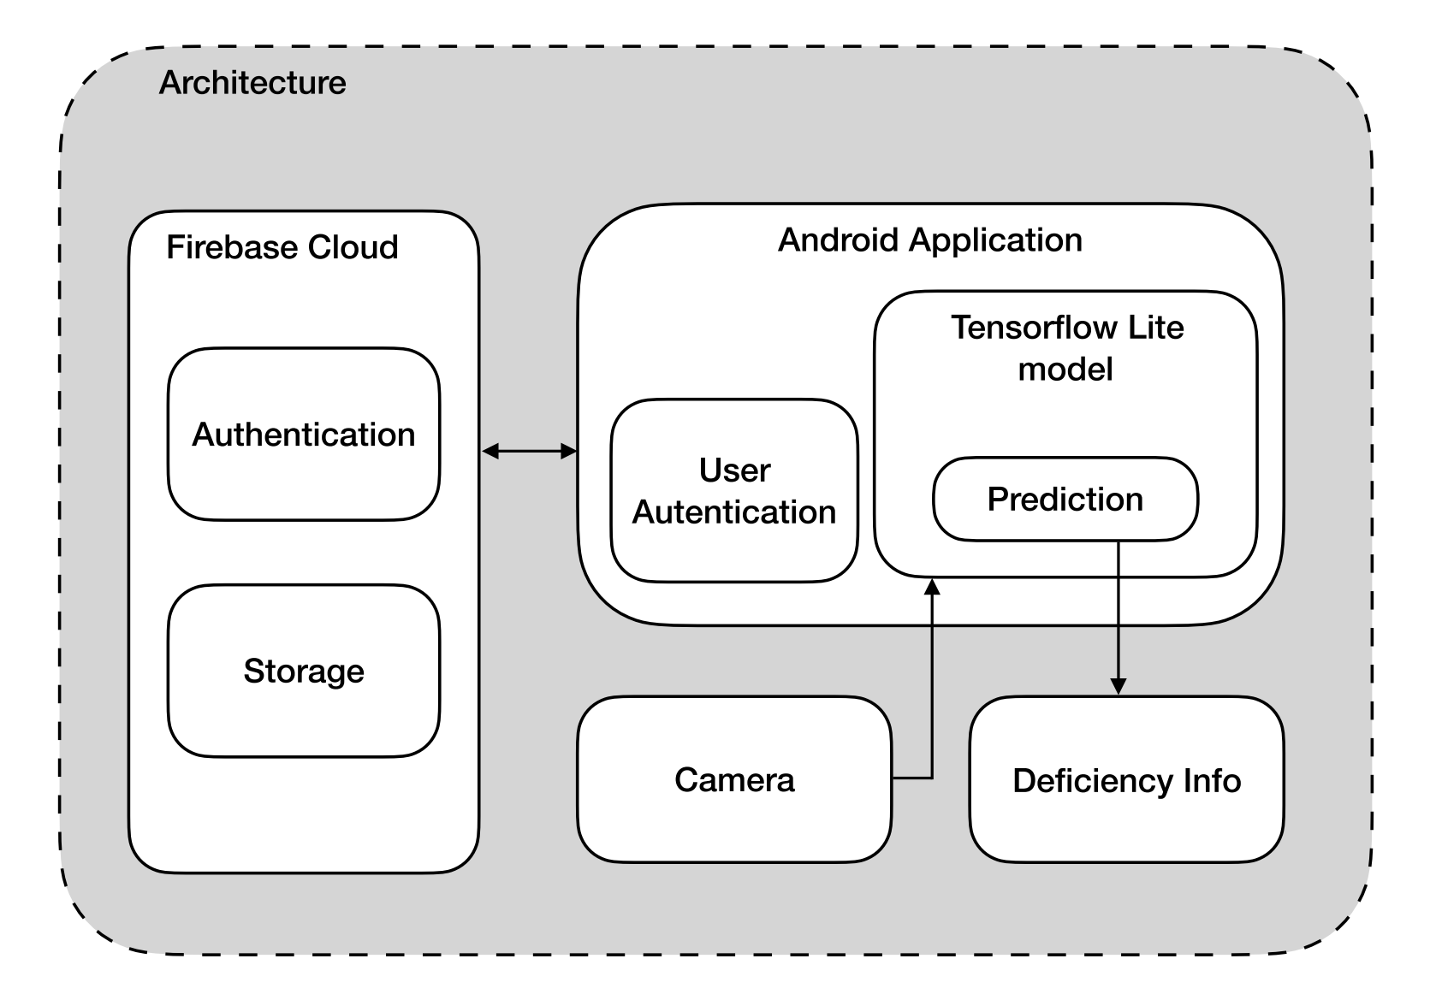

Fig-2: Architecture

**1. User Authentication:**

- The user initiates the process by accessing the Android application through a secure username and password authentication. This ensures that the system interacts only with authorized individuals, safeguarding user privacy and data integrity.

**2. Image Capture:**

- Following successful authentication, users are prompted to capture images of specific body parts—lips, nails, eyes, and tongue. These images serve as the input data for our model. The captured visuals are then stored securely in the database for subsequent training of the TensorFlow Lite model.

**3. Image Training and Processing:**

- The stored images undergo a rigorous training process within the TensorFlow Lite model. This model, embedded within our Android application, employs advanced Convolutional Neural Networks (CNN) and Fuzzy Logic to intelligently process and analyse the images. The model leverages insights gained from the training dataset to identify patterns and characteristics associated with various vitamin deficiencies.

**4. Deficiency Prediction:**

- Once the image processing is complete, the model predicts potential vitamin deficiencies based on the analysed images. The application then displays a detailed report highlighting the specific vitamins that may be lacking in the user's body. This information serves as a valuable starting point for users to address their health needs proactively.

**5. Dietary Recommendations:**

- To further assist users in addressing identified deficiencies, our system offers a recommended dietary plan. This plan is tailored to individual deficiencies and suggests specific fruits and vegetables known for their richness in the identified vitamins. By integrating nutritional guidance, our system goes beyond detection, encouraging users to make informed dietary choices for holistic well-being.

**6. User Interface and Experience:**

- Throughout the entire process, a user-friendly interface guides individual seamlessly. Clear instructions, intuitive design, and responsive feedback ensure a positive user experience. The application prioritizes accessibility, making health management an easy and empowering endeavour for users.

**7. Continuous Improvement through Feedback:**

- The system is designed to collect user feedback and experiences, fostering continuous improvement. User insights contribute to refining the model, enhancing accuracy, and expanding the knowledge base for more effective vitamin deficiency detection.

The seamless operation of our vitamin deficiency detection system unfolds through a meticulously designed sequence of steps, ensuring both security and user-friendly engagement. Commencing with User Authentication, individuals access the Android application securely, employing a username and password. This initial step guarantees that the system interacts solely with authorized users, prioritizing user privacy and preserving the integrity of their data.

Once authenticated, users are guided to the pivotal step of Image Capture. In this phase, they are prompted to capture images of specific body parts—lips, nails, eyes, and tongue. These images serve as fundamental input data for our sophisticated TensorFlow Lite model, and the captured visuals are securely stored in the database for subsequent model training.

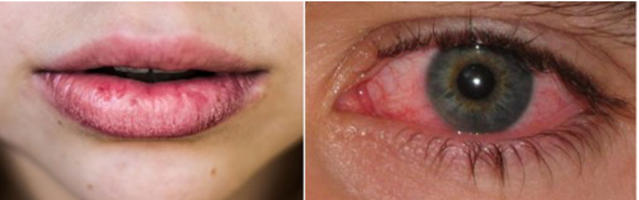

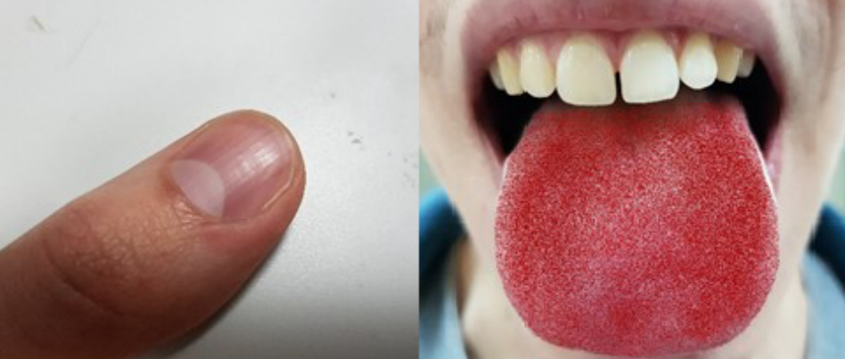

Fig-3: Sample Inputs

Moving into Image Training and Processing, the stored images undergo rigorous training within the TensorFlow Lite model. This embedded model employs advanced Convolutional Neural Networks (CNN) and Fuzzy Logic, intelligently processing and analysing the images. Leveraging insights gained from the training dataset, the model identifies patterns and characteristics associated with various vitamin deficiencies.

With the completion of image processing, the model proceeds to predict potential vitamin deficiencies based on the analysed images. The application then presents users with a detailed report highlighting specific vitamins that may be lacking in their bodies, serving as a valuable starting point for proactive health management.

To further assist users in addressing identified deficiencies, our system extends support through Dietary Recommendations. Tailored to individual deficiencies, the system offers a recommended dietary plan, suggesting specific fruits and vegetables known for their richness in the identified vitamins. This holistic approach transcends mere detection, encouraging users to make informed dietary choices for their overall well-being.

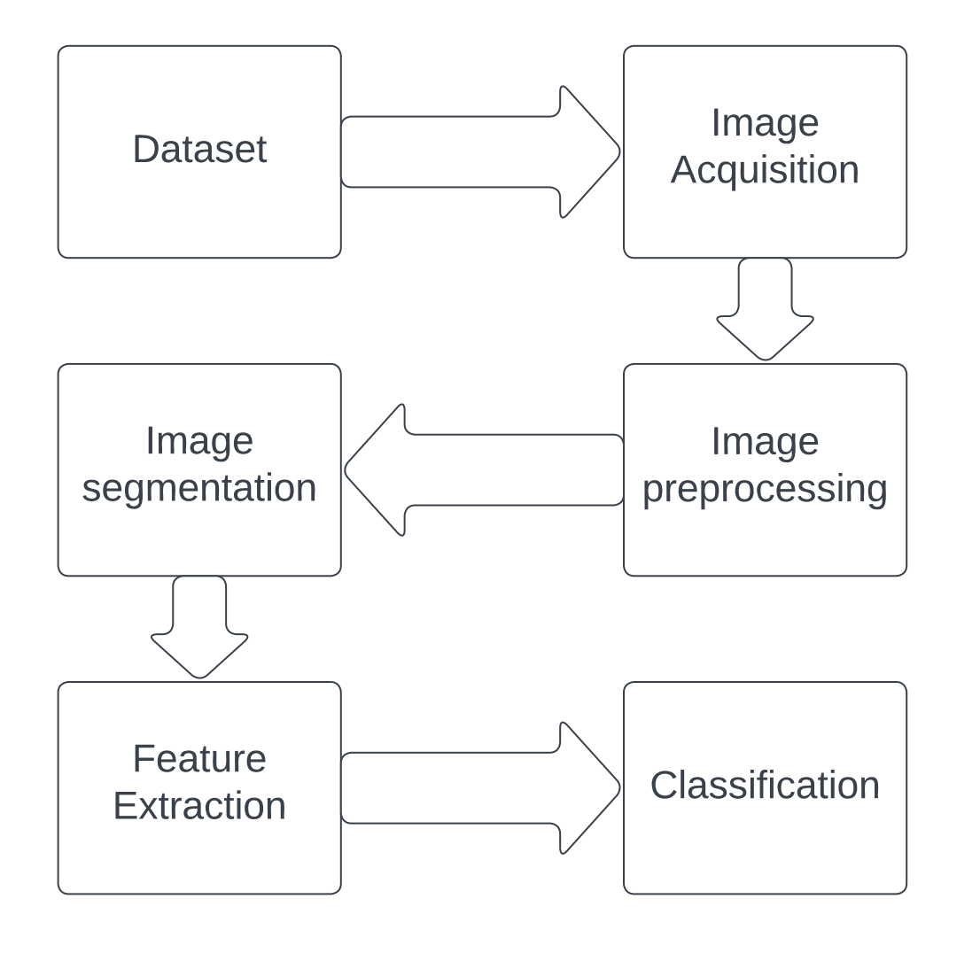

Fig-4: Visual data processing

Throughout this intricate process, the User Interface and Experience remain at the forefront. A user-friendly interface guides individuals seamlessly, featuring clear instructions, an intuitive design, and responsive feedback. The application prioritizes accessibility, ensuring that health management becomes an easy and empowering endeavour for users.

The system is designed for Continuous Improvement through Feedback. Users are encouraged to provide insights and experiences, contributing to the refinement of the model, enhancement of accuracy, and expansion of the knowledge base for more effective vitamin deficiency detection.

In essence, our methodology is a harmonious blend of cutting-edge technology and user-centric design, orchestrating a revolutionary approach to vitamin deficiency detection. From secure authentication to personalized dietary recommendations, each step is thoughtfully crafted to empower users in actively managing their health and well-being.

**5.2 Flowchart**

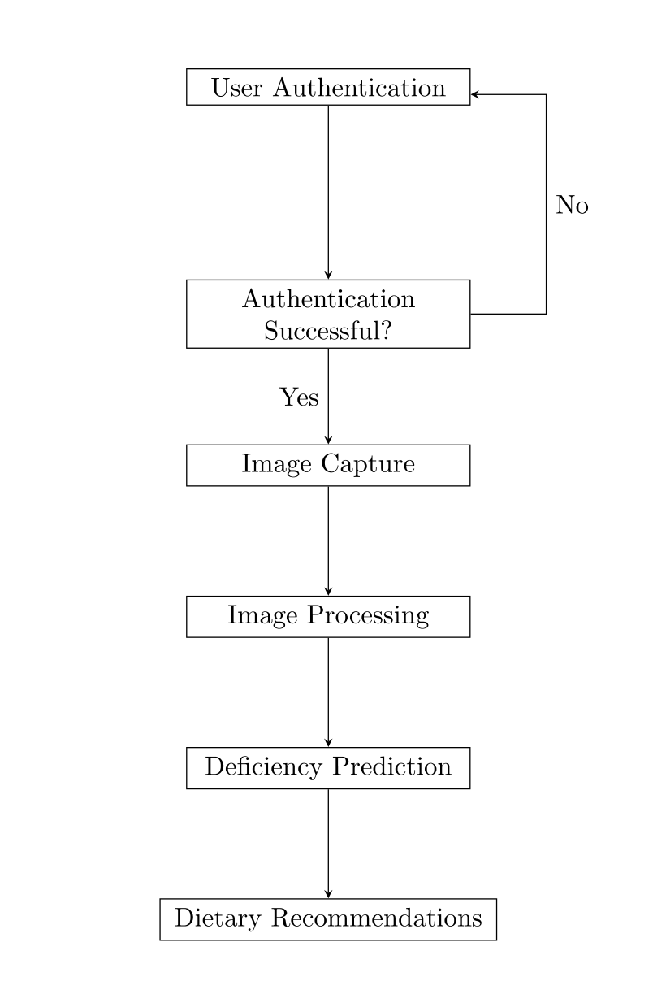

Fig-5: Flowchart

The proposed system involves a comprehensive process for vitamin deficiency detection through an Android application. The user initiates the process by authenticating through a username and password. Upon successful authentication, they proceed to capture images of specific body parts, including lips, nails, eyes, and tongue. These images are then stored for further training of a TensorFlow Lite model integrated into the application. The model processes the user's images, comparing them with a training dataset, and predicts any potential vitamin deficiencies. If the user authentication is successful, the system proceeds to image capture, image processing, deficiency prediction, and finally presents dietary recommendations. The user receives a personalized dietary plan suggesting healthy fruits and vegetables to address the identified deficiencies. This approach eliminates the need for invasive blood sample testing, providing a faster, cost-effective, and user-friendly alternative to traditional methods of vitamin deficiency detection.

**5.3 Tools and Technologies**

Our project leverages a robust set of cutting-edge tools and technologies to create an innovative and user-friendly vitamin deficiency detection system. For image processing and machine learning, we employ TensorFlow, a powerful open-source framework that enables efficient training and inference of neural networks. The model is implemented using Convolutional Neural Networks (CNN) for effective feature extraction from images, enhancing the accuracy of deficiency predictions. To ensure seamless integration with our Android application, we utilize TensorFlow Lite, a lightweight version optimized for mobile and edge devices. The development of the Android application is carried out using Android Studio, the official integrated development environment for Android app development. Google Colab, a cloud-based platform, facilitates collaborative model training and testing, providing a scalable and accessible environment for development. The integration of Fuzzy Logic into our system is achieved using MATLAB, contributing to intelligent decision-making based on image analysis results. These technologies collectively form a sophisticated framework, combining the strengths of machine learning, image processing, and mobile application development to deliver a comprehensive and efficient solution for vitamin deficiency detection.

**1. Google Colab:**

Google Colab, short for Colaboratory, is a free, cloud-based platform provided by Google that allows users to write and execute Python code collaboratively in a browser. Colab is built on top of Jupyter Notebooks, which are interactive documents that can include both code and rich text elements. Here are some key features and aspects of Google Colab:

1. Cloud-Based Computing: Google Colab provides a cloud-based computing environment, eliminating the need for users to set up their own local development environments. This makes it convenient for collaboration and easy access to computational resources.

2. Free Access to GPU and TPU: One of the standout features of Colab is the provision of free access to Graphics Processing Units (GPUs) and Tensor Processing Units (TPUs). This is especially valuable for machine learning tasks that involve training complex models, as these hardware accelerators significantly speed up computations.

3. Pre-Installed Libraries: Colab comes with many pre-installed libraries commonly used in data science and machine learning, such as NumPy, Pandas, Matplotlib, TensorFlow, and PyTorch. This makes it easy for users to start working on their projects without spending time on setup.

4. Integration with Google Drive: Colab is integrated with Google Drive, allowing users to save and share their Colab notebooks directly on Google Drive. This seamless integration simplifies version control and collaborative work.

5. Real-Time Collaboration: Multiple users can collaborate in real-time on the same Colab notebook. This makes it an excellent tool for team projects, where team members can see each other's changes and provide instant feedback.

6. Interactive Output: Colab supports the display of rich media outputs like images, HTML, and videos directly within the notebook. This makes it suitable for creating interactive and visually appealing documents.

7. Access to External Data: Colab allows users to access external data sources, including datasets stored in Google Drive or publicly available datasets on the internet.

8. Code Snippets and Examples: Colab provides code snippets and examples for various tasks, making it a valuable resource for learning and exploring new programming techniques and machine learning concepts.

Overall, Google Colab is a versatile and accessible tool for a wide range of data science and machine learning tasks, offering powerful computational resources without the need for significant setup or investment.

**2. TensorFlow:**

TensorFlow is an open-source machine learning framework developed by the Google Brain team. It is designed to facilitate the development and deployment of machine learning models, especially deep learning models. Here are key aspects and features of TensorFlow:

1. Flexible Architecture: TensorFlow provides a flexible and comprehensive ecosystem for building machine learning models. It supports various model architectures, including neural networks, and can be used for tasks like classification, regression, clustering, and more.

2. Symbolic Computation: TensorFlow uses a symbolic computation approach. Users define a computational graph that represents the operations of their model, and TensorFlow efficiently executes this graph. This allows for optimization opportunities and better performance.

3. Multi-Platform Support: TensorFlow is designed to work seamlessly across different platforms, including CPUs, GPUs, and TPUs (Tensor Processing Units). This makes it versatile for developing models that can run on a variety of hardware.

4. High-Level APIs: TensorFlow provides high-level APIs like Keras, which simplifies the process of building and training deep learning models. Keras serves as a user-friendly interface while leveraging the powerful capabilities of TensorFlow in the background.

5. Extensive Community and Resources: TensorFlow has a large and active community of developers and researchers. This results in abundant resources, tutorials, and pre-trained models available for users to leverage. The community contributes to the continuous improvement and expansion of TensorFlow's capabilities.

6. TensorBoard: TensorFlow includes TensorBoard, a visualization tool that helps users understand, debug, and optimize their machine learning models. It provides insights into metrics, model graphs, and other relevant information during the training process.

7. TensorFlow Lite: TensorFlow Lite is a version of TensorFlow designed for mobile and edge devices. It allows developers to deploy machine learning models on devices with resource constraints, such as smartphones and IoT devices.

8. Ecosystem Integration: TensorFlow integrates with various libraries and tools in the machine learning and data science ecosystem, making it compatible with popular frameworks like scikit-learn and libraries like NumPy.

9. Open Source and Active Development: TensorFlow is an open-source project, allowing developers to contribute to its development and customize it for their specific needs. The framework is continuously updated with new features and improvements.

10. Wide Adoption: TensorFlow is widely adopted in both academia and industry. Many research papers and state-of-the-art models are implemented using TensorFlow, making it a popular choice for machine learning practitioners.

Whether you are a beginner or an experienced machine learning engineer, TensorFlow offers the tools and flexibility needed to develop, train, and deploy machine learning models across a variety of applications and domains.

**3. TensorFlow Lite:**

TensorFlow Lite (TFLite) is a lightweight version of the TensorFlow machine learning framework specifically designed for mobile and edge devices. It enables developers to deploy machine learning models on devices with resource constraints, such as smartphones, tablets, IoT devices, and other embedded systems. Here are key features and aspects of TensorFlow Lite:

1. Optimized for Mobile and Edge Devices: TensorFlow Lite is optimized to run efficiently on devices with limited computational resources. It allows developers to bring the power of machine learning directly to end-user devices, enabling on-device inference without relying on a constant internet connection.

2. Model Size Reduction: To accommodate the constraints of mobile and edge devices, TensorFlow Lite employs model size reduction techniques. This ensures that machine learning models have a smaller footprint, making them suitable for deployment on devices with limited storage capacity.

3. Fast Inference: TensorFlow Lite is designed for low-latency inference, ensuring that predictions can be made quickly on the device. This is crucial for real-time applications, where immediate feedback or decision-making is required.

4. Quantization: TensorFlow Lite supports model quantization, a technique that reduces the precision of the model's parameters. This helps further reduce the model size and computational requirements while maintaining acceptable levels of accuracy.

5. Cross-Platform Compatibility: TensorFlow Lite supports various platforms, including Android, iOS, and embedded systems. This cross-platform compatibility allows developers to deploy models on a wide range of devices without major modifications.

6. Interpreter for On-Device Inference: TensorFlow Lite uses an interpreter for on-device inference. This interpreter allows the execution of trained machine learning models directly on the device, without the need for constant connectivity to a server.

7. Integration with TensorFlow: TensorFlow Lite seamlessly integrates with the broader TensorFlow ecosystem. Developers can train models using the standard TensorFlow framework and then convert them to the TensorFlow Lite format for deployment on mobile and edge devices.

8. Hardware Acceleration: TensorFlow Lite takes advantage of hardware acceleration when available. This includes support for hardware accelerators like GPUs (Graphics Processing Units) and specialized AI hardware, providing additional performance improvements.

9. Community and Documentation: TensorFlow Lite benefits from the TensorFlow community and has extensive documentation, tutorials, and resources available. This makes it easier for developers to get started with on-device machine learning and successfully deploy models.

10. Updates and Improvements: TensorFlow Lite is actively developed, with regular updates and improvements. This ensures that developers have access to the latest features, optimizations, and compatibility enhancements.

In summary, TensorFlow Lite is a crucial component for deploying machine learning models on mobile and edge devices. It addresses the challenges of limited resources by optimizing model size, ensuring fast inference, and supporting various hardware configurations. TensorFlow Lite empowers developers to create intelligent applications that run directly on users' devices, enhancing privacy, reducing latency, and enabling new possibilities for on-device AI.

**4. Convolutional Neural Networks:**

Convolutional Neural Networks (CNNs) are a class of deep neural networks designed for tasks involving visual perception, such as image and video recognition, image classification, object detection, and segmentation. CNNs are particularly effective in capturing spatial hierarchies of features in input data, making them well-suited for tasks where the arrangement and relationships of features matter. Here are the key components and concepts of Convolutional Neural Networks:

1. Convolutional Layers: The fundamental building block of a CNN is the convolutional layer. This layer applies convolutional operations to the input data, using learnable filters or kernels to extract local patterns and features. Convolutional operations involve sliding these filters over the input to perform element-wise multiplications and summations.

2. Pooling Layers: Pooling layers are used to down sample the spatial dimensions of the input, reducing computational complexity and focusing on the most essential information. Max pooling and average pooling are common pooling techniques applied to the output of convolutional layers.

3. Activation Functions: Non-linear activation functions, such as Rectified Linear Unit (ReLU), are applied to introduce non-linearity into the network. ReLU, for example, replaces negative values with zero, allowing the network to learn complex relationships and representations.

4. Fully Connected Layers: In the final layers of a CNN, fully connected layers are often used to make predictions based on the high-level features extracted by the convolutional and pooling layers. These layers connect every neuron to every neuron in the previous and subsequent layers, capturing global patterns.

5. Convolutional Filters: Filters in convolutional layers are learnable parameters that are adjusted during the training process. These filters act as feature detectors, recognizing patterns such as edges, textures, and more complex structures.

6. Stride: The stride in convolutional operations determines how much the filter is moved across the input. A larger stride reduces the spatial dimensions of the output, impacting the network's receptive field.

7. Padding: Padding involves adding extra pixels to the input data to preserve spatial information during convolutional operations. Padding helps avoid the reduction of spatial dimensions, which can be crucial in maintaining information at the network's edges.

8. Weight Sharing: CNNs leverage weight sharing, where the same set of filters is used across different regions of the input. This sharing enables the network to learn spatial hierarchies of features efficiently.

9. Hierarchy of Features: CNNs automatically learn hierarchical representations of features, starting from simple, low-level features (e.g., edges) in the early layers and progressing to more complex, high-level features (e.g., object parts and shapes) in deeper layers.

10. Transfer Learning: CNNs can benefit from transfer learning, where pre-trained models on large datasets (e.g., ImageNet) are fine-tuned for specific tasks. This approach leverages the learned features of the pre-trained model, saving training time and resources.

Convolutional Neural Networks have demonstrated remarkable success in various computer vision tasks, and their architecture is a key component in the development of image-based applications, including medical image analysis, autonomous vehicles, facial recognition, and more.

**5. Android Studio:**

Android Studio is the official integrated development environment (IDE) for Android app development. It is a powerful and user-friendly platform that provides developers with the necessary tools to design, code, test, and deploy Android applications. Here are some key features and components of Android Studio:

1. User Interface Design: Android Studio offers a visual design editor that allows developers to create the user interface of their Android apps using a drag-and-drop interface. This feature simplifies the process of designing app layouts and UI elements.

2. Code Editor: Android Studio includes a robust code editor with features like code completion, syntax highlighting, and real-time error checking. It supports various programming languages, including Java and Kotlin, which are the primary languages for Android app development.

3. Gradle Build System: Android Studio uses the Gradle build system to manage project builds and dependencies. Gradle allows developers to define project configurations and automate the build process. It also facilitates the integration of third-party libraries and modules.

4. Emulator: Android Studio comes with an emulator that enables developers to test their apps on virtual Android devices with different screen sizes, resolutions, and Android versions. This is crucial for ensuring app compatibility across a wide range of devices.

5. Debugging and Profiling Tools: The IDE provides robust debugging tools, including breakpoints, watches, and a real-time debugger. Additionally, developers can use profiling tools to analyse their app's performance, identify bottlenecks, and optimize code.

6. Version Control Integration: Android Studio integrates with version control systems like Git, allowing developers to manage and track changes to their codebase. This facilitates collaboration among team members working on the same project.

7. Template-Based Project Creation: Android Studio offers templates for creating different types of Android apps, such as empty activities, master/detail flow, navigation drawer, and more. These templates provide a starting point for developers, saving time on boilerplate code.

8. Support for Kotlin: Android Studio fully supports the Kotlin programming language, providing developers with a concise and expressive alternative to Java for Android app development. Kotlin has become an official language for Android development, and many developers prefer it for its modern syntax and features.

9. Google Play Integration: Android Studio is tightly integrated with the Google Play Store, allowing developers to publish and distribute their apps directly from the IDE. Developers can manage app releases, monitor user feedback, and access performance metrics.

10. Extensibility: Android Studio is extensible, allowing developers to enhance its functionality by installing plugins. These plugins can add new features, tools, and support for different technologies.

Android Studio is an essential tool for Android developers, providing a comprehensive and streamlined environment for building high-quality Android applications. Its constant updates and improvements reflect the evolving needs of the Android development community.

**CONCLUSION OF PHASE-1**

In the first phase our project, focused on early detection of vitamin deficiencies, drew valuable insights from a literature survey of key reference papers. The work by Ahmed Saif Eldeen and team laid the foundation with their paper on "Vitamin Deficiency Detection Using Image Processing and Neural Network (2020)," providing a strong basis for our approach using artificial intelligence and image analysis. We also benefited from research in plant nutrient deficiency detection by Anu Jose et al. (2021) and R. Sathyavani et al. (2021), exploring machine learning and convolutional neural networks in different contexts. Additionally, Zhe Xu et al.'s work on "Using Deep Convolutional Neural Networks for Image-Based Diagnosis of Nutrient Deficiencies in Rice (2020)" influenced our understanding of applying advanced technologies to agricultural scenarios. These references collectively guided our project's methodology, contributing to our goal of creating an effective and user-friendly system for vitamin deficiency detection.

**REFERENCES**

[1] Ahmed Saif Eldeen, Mohamed AitGacem, Saifeddin Alghlayini, Wessam Shehieb and Mustahsan Mir: Vitamin Deficiency Detection Using Image Processing and Neural Network (2020)

[2] Anu Jose, S Nandagopalan, Vidya Ubalanka and Dhanya Viswanath: Detection and classification of nutrient deficiencies in plants using machine learning (2021)

[3] R. Sathyavani, K. JaganMohan, B. Kalaavathi: Detection of plant leaf nutrients using convolutional neural network-based internet of things data acquisition (2021)

[4] Zhe Xu, Xi Guo, Anfan Zhu, Xiaolin He, Xiaomin Zhao, Yi Han, and Roshan Subedi: Using Deep Convolutional Neural Networks for Image-Based Diagnosis of Nutrient Deficiencies in Rice (2020)